12 Days of SoTL 2019

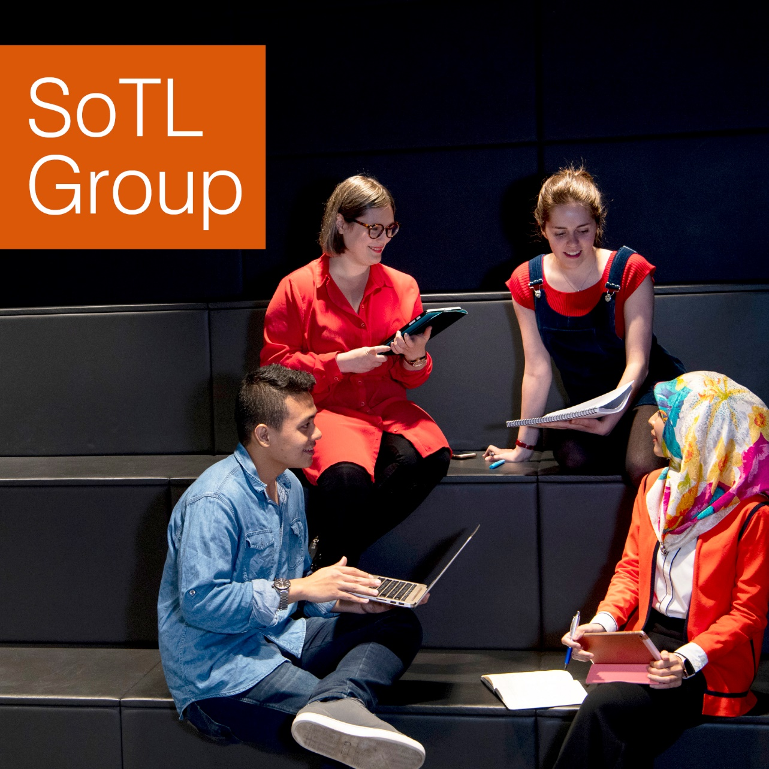
Contents
Day 01: Welcome and Where to Start 3
On Day One of SoTL: 3
Twelve Days of SoTL 3
Day 2: Research Questions 6
On Day Two of SoTL 6
Identifying collaboration opportunities 6
Day 3: Literature 8
On Day Three of SoTL 8
Introducing research indicators (bibliometrics and altmetrics) 8
Day 4: Theory 9
Day 5: Methodology 10
Day 6: Methods 11
On Day Six of SoTL: 11
Day 7: Participant Selection 12
Day 8: Ethics 13
Questions that usually need to be addressed are: 13
Additionally 13
Ethics Committee @UofG 13
Further Resources: 13
☃ British Educational Research Association Ethics Guidelines 13
Day 9: Data Collection 15
The SAGE Handbook of Interview Research: The Complexity of the Craft 15
Day 10 Data Analysis 16
Day 11: Write about your SoTL 17
Day 12: publish SoTL 18
ORCID, Enlighten and Research Identifiers 18

Day 01: Welcome and Where to Start

Welcome to the twelve days of SoTL 2019! If you want to follow the pursuits on Twitter, follow the #12daysofSoTL hashtag!
This MindMap gives you an overview of the process and includes links to various resources you might find helpful: https://mm.tt/1365616325?t=60QxBONf3C
I made this MindMap fully editable so if you have questions or want to add things please feel free to do so. You should also be able to export this as a MS Word document, so it translates the MindMap into something linear if this works better for you.

On Day One of SoTL:
We would look into what interests you in either your teaching or your students' learning? Or is in fact your interest in the interplay between the both?
Or is there something that flummoxes you? Or something that you never quite get right and don't know why?
Today is the day to try and formulate this!
To start you of gently and take the pressure out of the topic why not sing along 

Twelve Days of SoTL
On the first day of SoTL
My AcDev sent to me
A question for an educational inquiry
On the second day of SoTL
My AcDev sent to me
Two ethics amendments
And a question for an educational inquiry
On the third day of SoTL
My AcDev sent to me
Three theoretical frameworks
Two ethics amendments
And a question for an educational inquiry
On the fourth day of SoTL
My AcDev sent to me
Four methodology choices
Three theoretical frameworks
Two ethics amendments
And a question for an educational inquiry
On the fifth day of SoTL
My AcDev sent to me
Five different methods
Four methodology choices
Three theoretical frameworks
Two ethics amendments
And a question for an educational inquiry
On the sixth day of SoTL
My AcDev sent to me
Six data management tool
Five different methods
Four methodology choices
Three theoretical frameworks
Two ethics amendments
And a question for an educational inquiry
On the seventh day of SoTL
My AcDev sent to me
Seven participant samples
Six data management tool
Five different methods
Four methodology choices
Three theoretical frameworks
Two ethics amendments
And a question for an educational inquiry
On the eight day of SoTL
My AcDev sent to me
Eight Codes in NVivo
Seven participant samples
Six data management tool
Five different methods
Four methodology choices
Three theoretical frameworks
Two ethics amendments
And a question for an educational inquiry
On the ninth day of SoTL
My AcDev send to me
Nine cluster samples
Eight Codes in NVivo
Seven participant samples
Six data management tool
Five different methods
Four methodology choices
Three theoretical frameworks
Two ethics amendments
And a question for an educational inquiry
On the tenth day of SoTL
My AcDev send to me
Ten correlations
Nine cluster samples
Eight Codes in NVivo
Seven participant samples
Six data management tool
Five different methods
Four methodology choices
Three theoretical frameworks
Two ethics amendments
And a question for an educational inquiry
On the eleventh day of SoTL
My AcDev send to me
Eleven references
Ten correlations
Nine cluster samples
Eight Codes in NVivo
Seven participant samples
Six data management tool
Five different methods
Four methodology choices
Three theoretical frameworks
Two ethics amendments
And a question for an educational inquiry
On the twelfth day of SoTL
My AcDev sent to me
Twelve annoying comments
Eleven references
Ten correlations
Nine cluster samples
Eight Codes in NVivo
Seven participant samples
Six data management tool
Five different methods
Four methodology choices
Three theoretical frameworks
Two ethics amendments
And a question for an educational inquiry

Day 2: Research Questions
On Day Two of SoTL
Think about your research question. If it is easier for you to begin with formulating a hypothesis this is a valid starting point. Later down the line we can have a chat about how we would go about proving or disproving this hypothesis.
Chapter three of this book might help you work your way through formulating a research question:
Gilbert, G. N., & Stoneman, P. (2016). Researching social life (Fourth ed.). Los Angeles: Sage.
For #TeamUofG library permanent link is here: https://eleanor.lib.gla.ac.uk/record=b3146753
One of the main tips I would give for today is, begin to write down everything that is in your head around your questions. When running SoTL CPD and research methods courses, we often encounter people arriving with already formed methods, how they want to collect data and when. Take a step or two back and touch base with what is it you actually want to know. It might be that what you had planned on doing would not answer your question. Try not to be tempted to go for data collection methods just because you are familiar with them. Even if it is daunting but we are here to help.
Once you know what you want to explore, why not join our SoTL Teams
https://teams.microsoft.com/l/team/19%3a34706628dab34db2b73b028244d987f6%40thread.skype/conversations?groupId=0bfcf7ff-4ee5-4066-a56b-daa01a25cc52&tenantId=6e725c29-763a-4f50-81f2-2e254f0133c8

and find colleagues from across the institution for collaboration?

Or join the library webinar next week on

Identifying collaboration opportunities

https://event.bookitbee.com/25413/identifying-collaboration-opportunities

There is also one more SoTL CPD session in Southpark House, on Observation as research method: https://www.gla.ac.uk/myglasgow/leads/events/index.html/event/11485
For more SoTL CPD please see here: https://www.gla.ac.uk/myglasgow/leads/goodpractice/cpd/#/scholarshipofteaching&learningstrand(andsotlgroupinfo)

Day 3: Literature

On Day Three of SoTL
We are thinking about the literature review. The tricky bit with this area is, if you are not from a cognate discipline, your usual research databases might not yield many or any relevant results for your question. Education is a multidisciplinary field relating to education, psychology, educational psychology, neuro-and cognition sciences, philosophy, politics, sociology and so forth. The questions you are having might necessitate research across various disciplines.
This might be the point in time where I ought to highlight that #TeamUofG librarians have approached me to ensure that they are happy to support you in identifying the appropriate literature for your SoTL projects, and in a first instance to explore this website: https://www.gla.ac.uk/myglasgow/library/staff/researchsupport
There are various compilations of journals which you might want to refer to for articles, I started to put an open document together which collates some of journals but also can help you manage writing your publications on Google Drive:
https://drive.google.com/file/d/1QkZqPX9jgPIIkCR3Q9VEKKUwsRY5C-T1/view?usp=sharing
And there is a list of journals mainly focusing on digital learning:
https://www.dcu.ie/nidl/resources/online-journals.shtml
Typical databases we would refer to would be:

- JSTOR https://www.jstor.org/
- Ingentaconnect https://www.ingentaconnect.com/
- ERIC https://eric.ed.gov
- Main Publishers are Wiley, Sage, and Routledge

Join Next week's webinars:
Our librarians are running a week of lunch time webinars. You can book your place here:

Introducing research indicators (bibliometrics and altmetrics)

https://event.bookitbee.com/25415/introducing-research-indicators-bibliometrics-and-

Day 4: Theory

Theories are used often as a frame of reference. Exploring issues related to learning and teaching are influence by a complexity of variable and influencing factors. Theories can help us to scaffold our explorations and provide a lens through which to look. A theory is usually a concept that has an established body to proof (a paradigm is a concept without such a body of proof).

A couple of days ahead of our method day here in the advents calendar, a CPD session on observations. This session offers an overview of the principles of observation as a research method. We'll discuss issues around observation bias, interference with the observed, 'going native', and the significance of data derived through observation.
https://www.gla.ac.uk/myglasgow/leads/events/index.html/event/11485

Have a look at my take and super-simplified overview of educational theories.
https://www.youtube.com/watch?v=eI8jSU6RRsI

If you are confused about Ontology and Epistemology: Nicole and I created this clip to highlight some of the discussions, we had preparing our masters research course.

Day 5: Methodology

Methodology is your research (inquiry) plan or strategy. You could think about it as a project plan, answering how you go about answering your research questions (or proofing your hypothesis). What theoretical framework have you chosen to scaffold your research (if you choose one)? Have you decided to follow a methodology? There is a wide range of existing methodologies you can draw from such as Narrative Inquiry, Ethnography, Grounded Theory, Action Research. These will come with suggested tools (methods) and types of analysis. However, you can create your own approach appropriate to your situation. So you methodology chapter should answer:

- What methodology have you chosen and why?
- How do they help you answer your questions?
- Were there other approaches you could have chosen?
- What makes yours the most appropriate?
- How does your methodology (research approach) match your theoretical framework (if you choose one)?
- What methods are coming out of your methodology?
- What other methods could you have chosen and what makes the ones you choose the most appropriate?
- Explain the methods.
- Explain participant sampling.
- Explain ethical considerations.

The following video explains how a methodology chapter is usually approached in educational inquiries & research:
https://www.youtube.com/watch?v=zQFSNB-0sfQ&list=PL6EF44B354AD54CA0&index=2&t=2s

In the YouTube video below Nicole explains the origins and development of Grounded Theory:

Day 6: Methods

On Day Six of SoTL:
We think about our data collection methods. Do our methods actually answer our questions?
Ask yourself, if you have a small group of student (10 or 20) how valuable is the data you get from a questionnaire with Likert Scale answers? Are you too worried to try something new? What about a tweak to this method? Use open answer questions for some more in depth insights?
Methods are your tools. Your methods is how you collect your data, or where you get your data from. Like any tool, one standard way of collecting data might not work in your specific case. You might have to tweak the tool or use different tools to collect data in different ways to compare and contrast (data triangulation).
A real-life equivalency
It is a little bit like using a tap and die because the screws you have in your toolbox don’t fit and you need to cut a different size of screw. Or you live at a high altitude you might have to decrease the amount of yeast for your bread recipe as you would use at low level ground. Methods whilst often having agreed descriptors and applications, are often adapted to the situation. This is why you find so many variations.
An actual example
Take for instance photography as a research method. Initially, under a more positivist viewpoint, the items seen on the photographs were considered simply a depiction of a mutually understood reality. These methods can be helpful, and for instance highlight how much graffiti and doodles are on the benches in lecture halls and what they say. Photography can also be used as a focus point for interviews, to ease interview situation and gain better insights.
Other visual research left the taking of photographs to the participants, and their stories about the things depicted provide much richer insights into their experience, and will show the researchers very quickly that what we think we see is not necessarily what the participants see. This visual research method can be expanded into rich pictures, where participants draw, or create collages. You can see how complexity of a method can be tweaked and expanded according to the purpose of why you are using the method.
My colleagues were so generous to share their CPD slides about the various methods they taught, which I collated into this Sway presentation:
https://sway.office.com/Hg8FfzfRlnB66A48?ref=Link
There is an interesting series of YouTube videos exploring the question: What is data? This is the link to the playlist:

Day 7: Participant Selection

Participant selection can be a tricky issue particularly when we are undertaking an education inquiry with our own students. There is a variety of sampling techniques (probability and non-probability sampling methods) we can refer to:
- Cluster Sampling
- Snowball Sampling
- Convenience Sampling etc
Convenience sampling is most likely to be your easiest and most often used form of sampling as it means exactly what it says on the tin. You have easy access to the participants, and they are willing to participate. There are of course disadvantages to all the techniques. Your convenience sampling might be representative of your classroom but not be representative of characteristics of the wider field, e.g.: age, socio-economic factors.
Have a look at the resources colleagues from Statistics have provided:
http://www.stats.gla.ac.uk/steps/glossary/sampling.html

Also, The SAGE Dictionary of Social Research Methods is a really good resource to explain briefly and clearly different aspects you can use in your SoTL projects. To #TeamUofG it’s available as online book:
http://methods.sagepub.com.ezproxy.lib.gla.ac.uk/reference/the-sage-dictionary-of-social-research-methods

At this point you may have noticed that in educational inquiries, as a multidisciplinary field we make use of research strategies from different disciplines and subjects. This is to do with the nature of education. Gudjons (1999) already pointed out the complexity and interrelationship of the different fields of interest in education. Some, such as educational psychology, developed into distinct disciplines into themselves.

Gudjons, H. (1999) Pädagogisches Grundwissen. 6th ed. Bverlag Julius Konkhardt. Bad Heilbrunn.

Day 8: Ethics

Ethics is always necessary when undertaking (non-clinical) research which involved people.

Questions that usually need to be addressed are:
- Why are you undertaking the research?
  - Your rationale.
- How do you plan to undertake the research?
  - Methodology
  - Methods
- Who are you participants?
  - How do you choose them?
- Are there any risks for your participants?
  - If so how do you plan on mitigating these?
- How and where do you store your data?

Additionally
You need to develop a participant information form, also called a plain language statement, which is for the participants to keep.
You also need to develop a consent form, asking for consent for each of the research methods and this is for your to keep.

Ethics Committee @UofG
Each of the colleges has it’s own ethics committee, whilst the information about ethics is on the websites:
- College of Arts https://www.gla.ac.uk/selfservice
- College of MVLS https://www.gla.ac.uk/selfservice
- College of Science and Engineering https://www.gla.ac.uk/selfservice
- College of Social Sciences https://www.gla.ac.uk/selfservice

The actual application forms and process is handled under MyCampus Business Systems. If you do not see an Ethics option under business systems please contact the helpdesk and asked to be added: https://www.gla.ac.uk/selfservice

Further Resources:

- British Educational Research Association Ethics Guidelines https://www.mindmeister.com/1372878760?t=60QxBONf3C
- Research Gateway https://www.gla.ac.uk/myglasgow/staff/theresearchgateway/
- Data Management https://www.gla.ac.uk/selfservice
- University Ethics committee https://www.gla.ac.uk/research/strategy/ourpolicies/ethics/

Library webinars this week. Why not join and find out how the library can support your SoTL activities? https://event.bookitbee.com/university-of-glasgow-library-events

Day 9: Data Collection

On day nine we reflect that whilst we have chosen our methods, there are some considerations to take when it comes to actually ‘doing the collecting’ of data.
For instance:
If we are leading interviews, and instead of having open ended questions, or even just prompts to encourage a free flow conversation, but we ask specific questions and want to be able to compare the exact answers given to each of the questions. The interviewer influence must be considered in more detail. As this can change how participants answer the questions. For instance:
- is the interviewer responsible to mark the participants assignments or exams,
- how senior in the interviewer,
- if there are different interviewers could this in itself have an impact on the participants answers
If we run focus groups, do we have a strategy if one or two people take the lead of the conversation and create either some peer pressure or a group think effect? Or do we let the conversation flow or are we asking very clear and specific questions, and prevent participants from straying off topic?
#TeamUofG Library Resource

The SAGE Handbook of Interview Research: The Complexity of the Craft
https://dx-doi-org.ezproxy.lib.gla.ac.uk/10.4135/9781452218403
Is our questionnaire tested so it actually answers what we are asking?

Day 10 Data Analysis

As with any of the previous topics I could probably run several 12 days of SoTL just for this topic.
There is a variety to data analysis processes or frameworks you can refer to. Some of which @UofGLEADS offers CPD for.
Thematic Analysis:
is probably the easiest approach if you are undertaking qualitative research for the first time. And I highly recommend the following article which does not only provide a clear explanation but also offers a bit of background to the approach.
Braun, V., Clarke, V., Hayfield, N., & Terry, G. (n.d.). Thematic Analysis 48. https://doi.org/10.1007/978-981-10-5251-4_103
Statistical analysis:
again have a look at the resource our colleagues have created
http://www.stats.gla.ac.uk/steps/glossary/paired_data.html
Questions of reliability and validity also need to be answered. Although these are approached different between qualitative and quantitative research approaches:
- https://www.statisticshowto.datasciencecentral.com/reliability-validity-definitions-examples/
- Emden, C., Sandelowski, M. (1998) The good, the bad and the relative, part one: Conceptions of goodness in qualitative research. International Journal of Nursing Practice vol: 4 issue: 4
doi: 10.1046/j.1440-172X.1998.00105.x
- Brink, H. (1993). Validity and reliability in qualitative research. Curationis, 16(2), 35-38. doi:https://doi.org/10.4102/curationis.v16i2.1396

Day 11: Write about your SoTL

Very often in SoTL, and specifically when we engage in a reflexive practice piece, we would write in 1st person, which can feel very awkward when you are used to writing in 3rd person. Whilst there is nothing intrinsically wrong with writing in 3rd person, you will still have to acknowledge your positionality towards your research.
Very often time and headspace to write are significant obstacle, I reflected on some learning from a coaching session with a writing coach here: https://activehighered.blog/2019/08/19/how-to-get-back-into-academic-writing/
Also please feel free to drop-in any time during the online writing session, where we undertake goal setting and keep the video open in the background to create that peer-environment which is so successful in writing groups. So far the feeback was positive. However, you can also join to ask question, as the software I am using permits breakout rooms so people can have discussions without disturbing anyone. The next writing session is:
Monday, the 16th of December from 9-11 am here: https://uofglasgow.zoom.us/j/553720814
You can also follow the academic writing community on Twitter with #AcWri or #AcWriMo or #AcademicWriting hashtags.

Day 12: publish SoTL

Today is a list of journals and resources that can help you to find the right place:
I created an OER where you can collate appropriate journals and plan your writing process
https://drive.google.com/file/d/1QkZqPX9jgPIIkCR3Q9VEKKUwsRY5C-T1/view?usp=sharing
Our colleague Sarah Honeychurch also shared a list of Digital Learning Journals in the SOTL group:
https://www.dcu.ie/nidl/resources/online-journals.shtml

Common Databases which can help you to find appropriate journals are:
- JSTOR https://www.jstor.org/
- Ingenta Connect https://www.ingentaconnect.com/
- ERIC https://eric.ed.gov

If you want to join our SoTL community and discuss questions you have or make suggestions why not drop in any time between 14:00-15:30 on Monday the 16th of December here: https://uofglasgow.zoom.us/j/462842297 ?

Also have a look at the Playlist featuring different editors from Journal for Learning and Teaching in Higher Education, who were interviewed at the dissemination fair last year. https://www.youtube.com/playlist?list=PLUtE5AlmlvhUyy9VFH-2uFRXMhIobM4cj

Today the library is running a webinar on managing your publications:

ORCID, Enlighten and Research Identifiers

https://event.bookitbee.com/25414/orcid-enlighten-and-research-identifiers

Enjoy the holidays once they come around!

